The COVID-19 virus is impacting the Bay Area Music community in many ways that affect both individual musicians’ livelihoods and the longevity of the venues where local musicians perform. These impacts threaten to transform our regional musical landscape.

In response, a group of local music non-profits are collaborating to advocate for independent musicians in this time of need, including Center for New Music (C4NM), Intermusic SF, Jazz in the Neighborhood, and Bird and Beckett Books and Records. In order to know how best to support artists, our community needs accurate information about how deeply and in what ways the crisis is hurting local musicians. Led by C4NM and Lisa Mezzacappa, this survey was sent out to the organizations’ members and followers through social media and email, and 425 participants responded.

Career Identity and Sources of Income
The vast majority of participants identified as musicians and a majority of participants also reported that freelance performing was their main source of income. Other significant income streams included music education, composing, and music production-related work.

Which of the following best describe you?
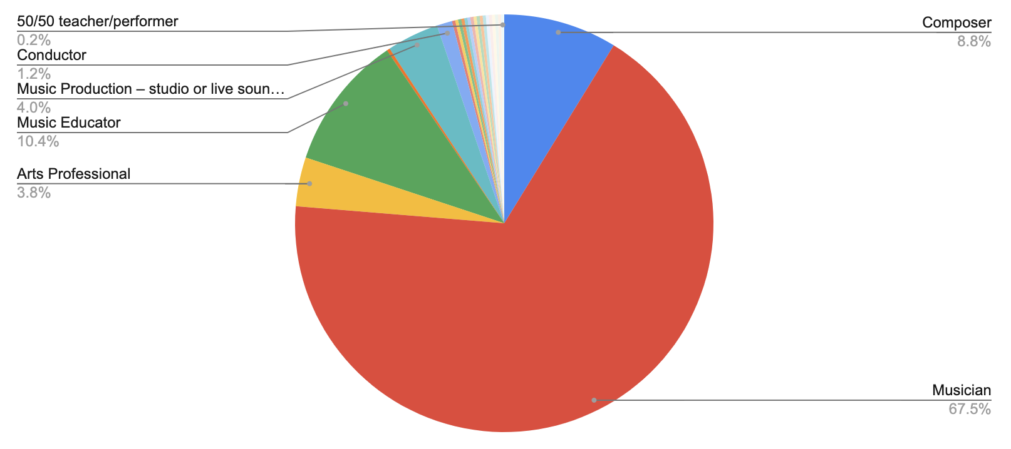
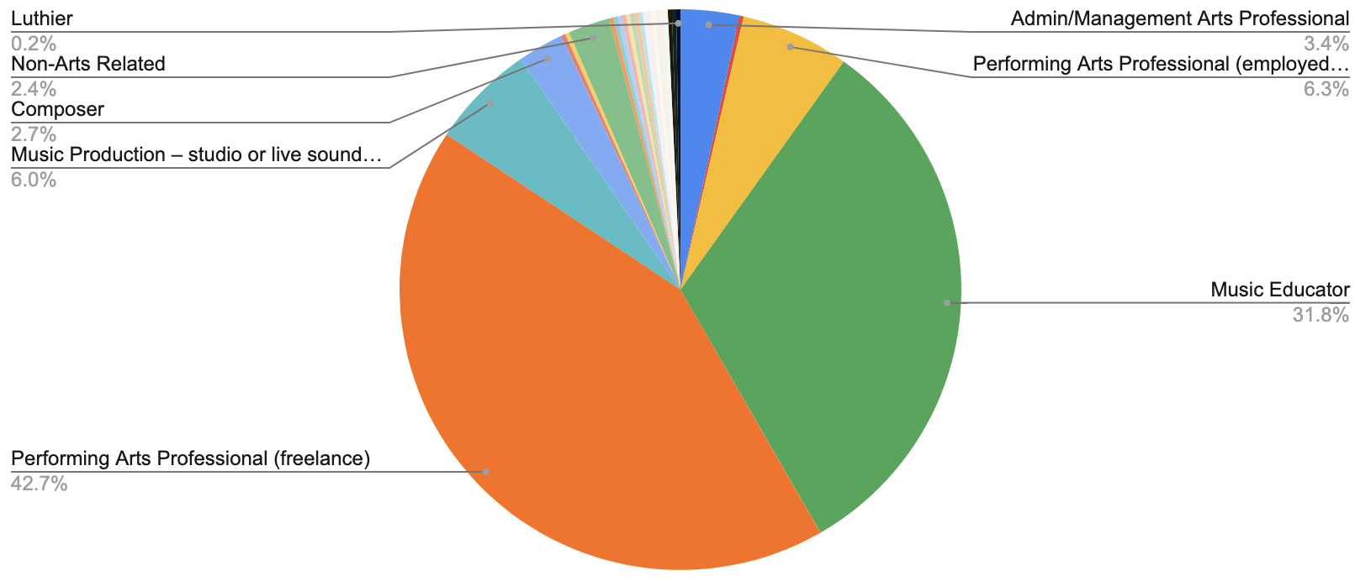

Top category from which you derive the majority of your income?

Please select a second category from which you also derive significant income.
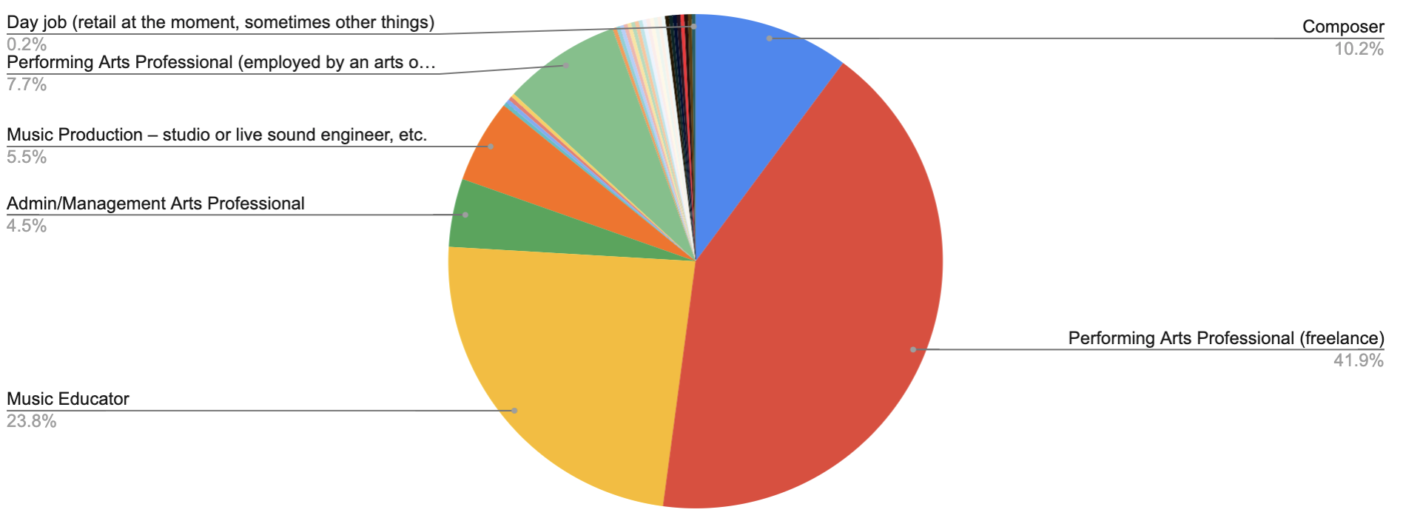

Musical Styles and Affiliations

To best understand what types of musicians contributed to our cohort, we assessed for musical genres and organizational affiliations. Because artists often work in multiple genres, we allowed participants to choose more than one genre, and the graphic below represents the total number of responses. Common combinations of genres included Jazz + Improv + Experimental; Contemporary/Post/Modern Classical + Orchestral + Chamber; Experimental + Electronic; Electronic + Multiple Genres; Chamber Music + Jazz; and Chamber Music + Orchestral. In general, our survey population was well distributed across the broader Jazz (Improv/ Jazz/ Experimental), and Classical (Chamber Music, Orchestral, Contemporary Classical) worlds. While a few musicians wrote in “Rock” or “Pop” this artist population was not well represented, as the affiliate organizations who shared this survey primarily serve non-commercial musicians.

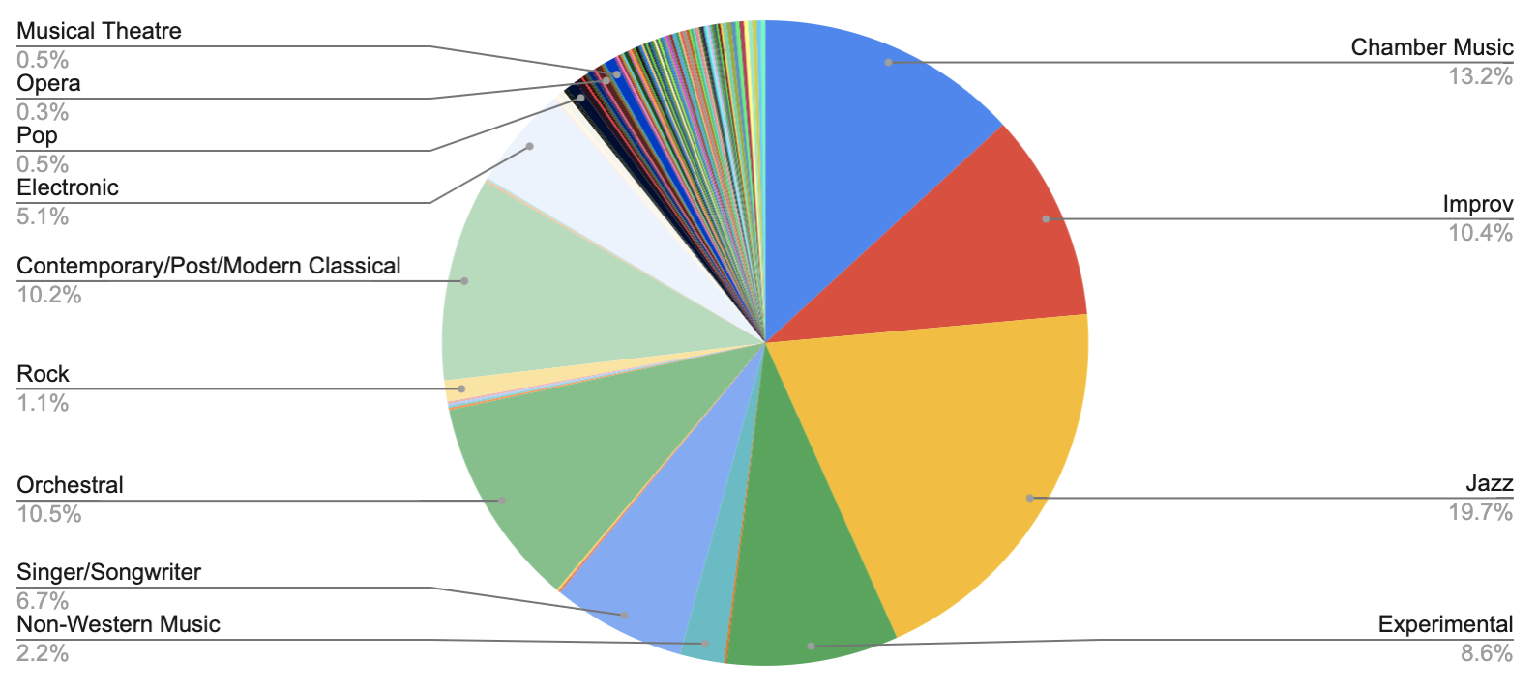
Musical Genres: Check all that apply.
Affiliations: Please check all that apply.
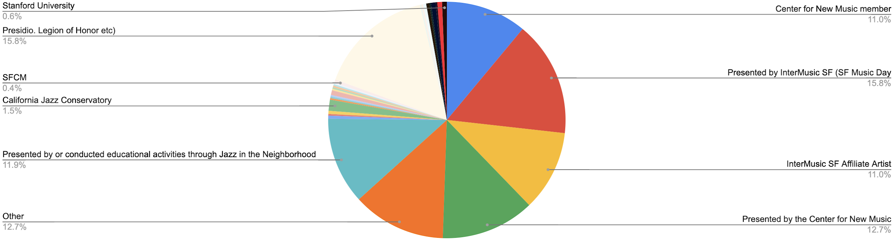
Places of Residence and Work

The survey participants live and work in the Bay Area. The majority of artists live in San Francisco, Oakland, and Berkeley, in that order. The majority of artists work in San Francisco, Oakland, and Berkeley, as well; however, a larger percentage of the work is focused in San Francisco compared to all other local areas.

Where Do You Live?
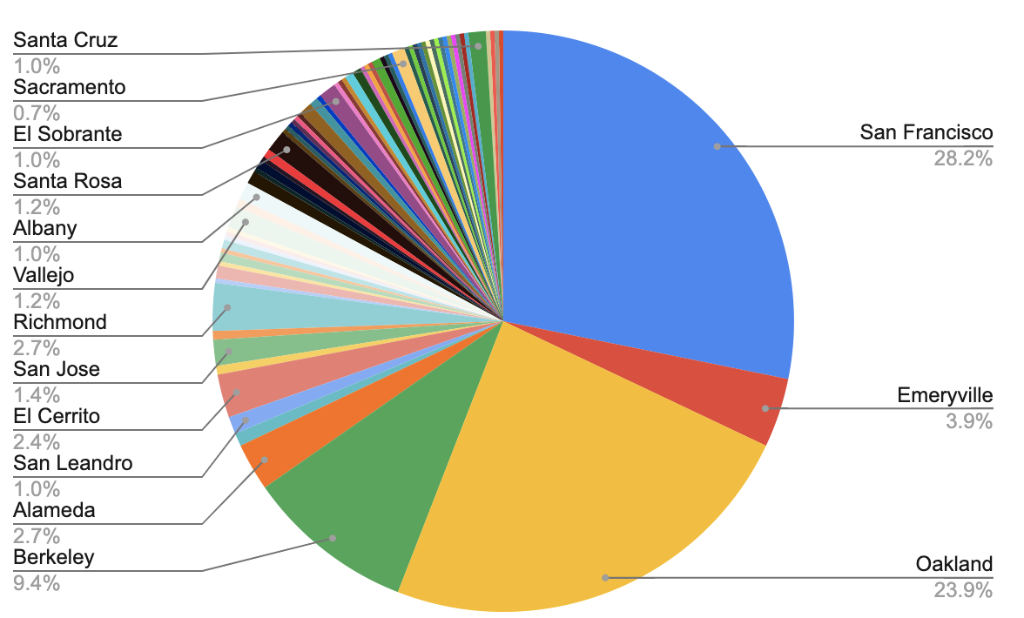
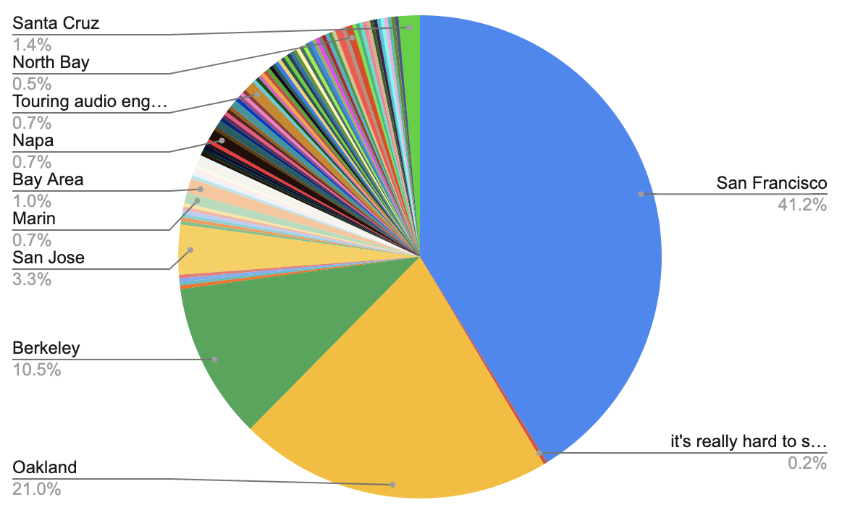
Where Do You Do Most of Your Work?

Questions for Teachers

Of the 425 participants, 262 reported that they were music teachers of some sort. The majority of teachers are reporting a loss of income. That is paired with the other findings of this study which show teachers are also hit with new expenses for getting their studios up to speed for online teaching, which all paints a tough picture for music teachers. On the second question, the majority of teachers marked “No” which suggests that they might not understand that they could qualify for unemployment under the new law.***

If you are a music teacher, have you been able to continue teaching lessons online without significant loss of income?
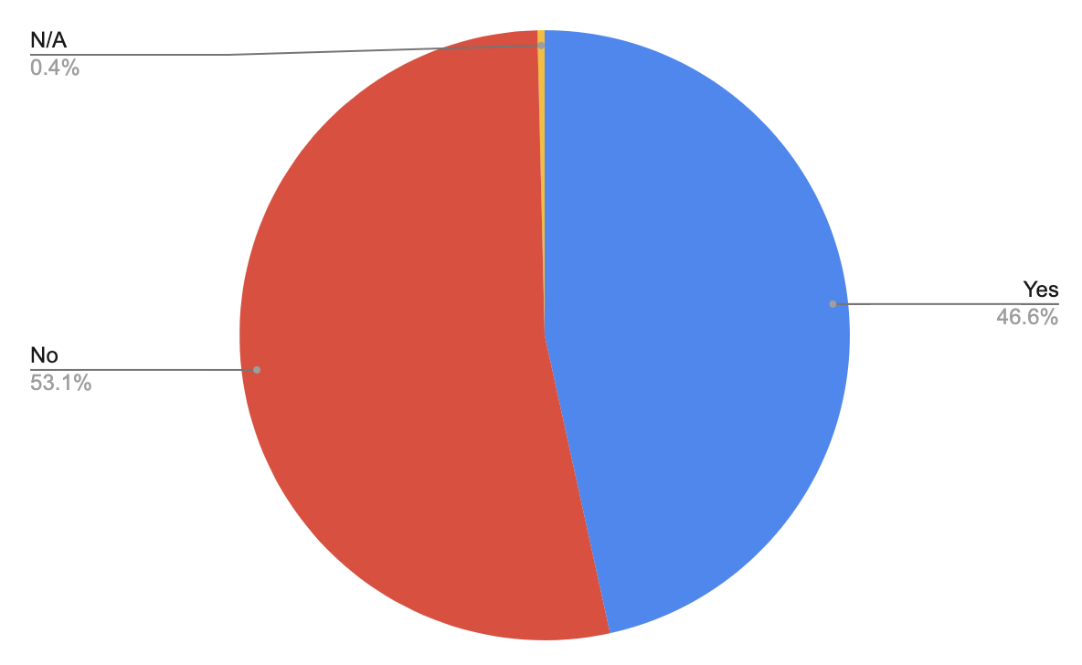
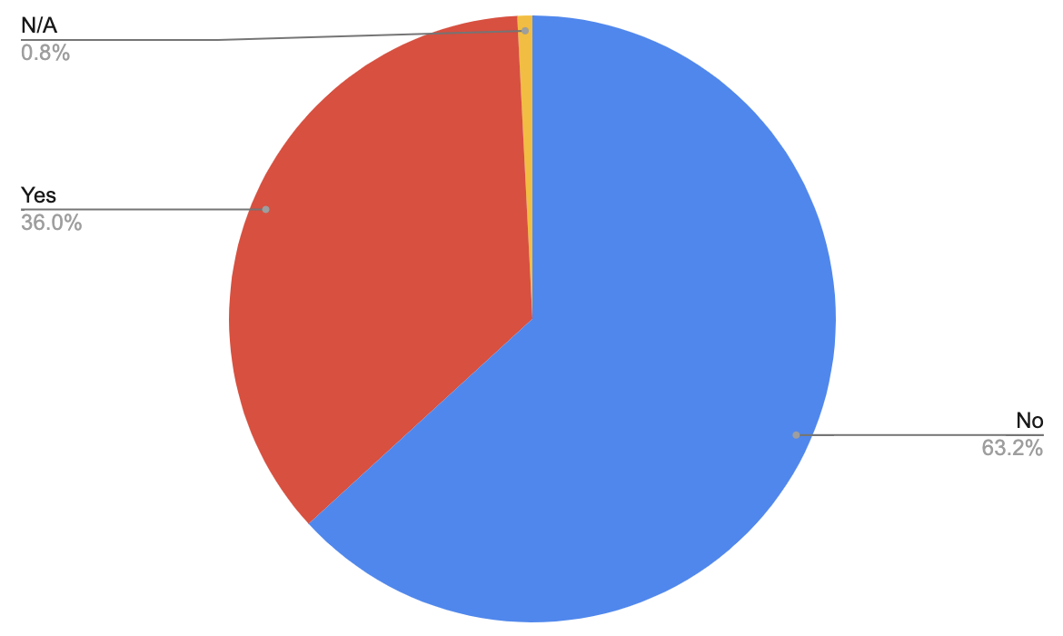
If you teach at a school, will you be able to collect unemployment benefits in the event the school closes or puts you on furlough? (125 school teachers responded)

Unemployment Questions

The following questions highlight that there is uncertainty and a lack of information about what is needed to file for unemployment. Furthermore, it appears that the majority of artists don’t have diverse income streams/ employers (i.e. ‘day jobs’) to qualify for unemployment through.

Federal/state COVID-19 aid allows self-employed people to have access to unemployment benefits. Do you have the necessary documentation of your lost wages as a self-employed musician?.
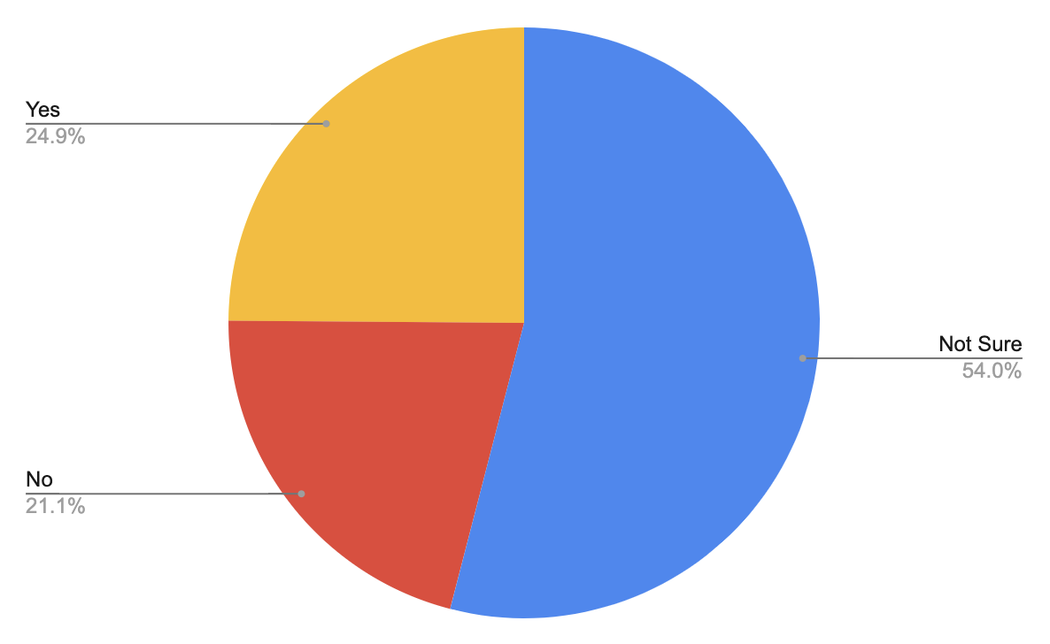
Do you have any other full or part-time employment (aside from your music career) through which you will be able to collect unemployment benefits in the event the job closes or puts you on furlough?
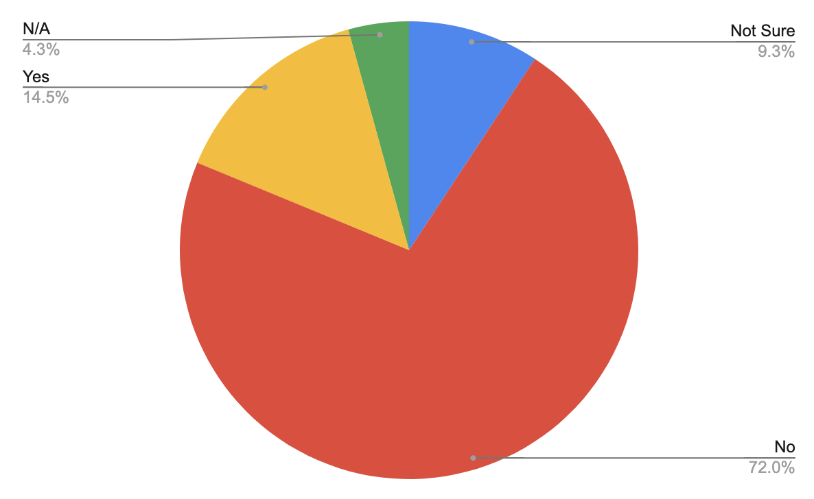

COVID-19 Direct Impacts

The financial impact on musicians should not be underestimated. The vast majority of musicians have a large number of events canceled and are reporting severe financial implications.

How many of your planned concerts/performances or music-related activities have already been canceled (not postponed) as a result of COVID-19?

Average | 14.6
Median | 10
Mode | 10

How much income do you estimate you have already lost as a result of COVID-19 cancellations?
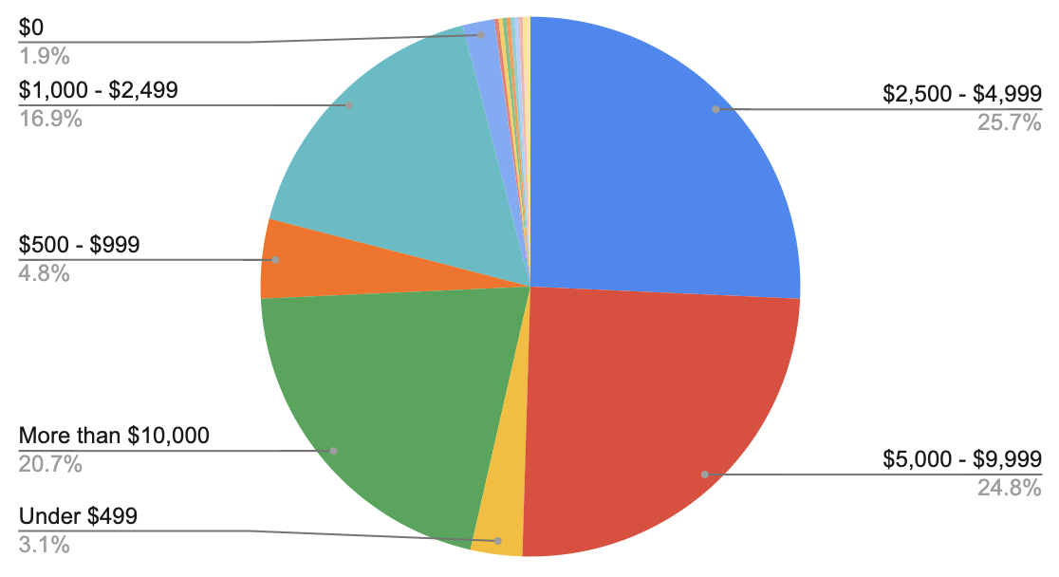
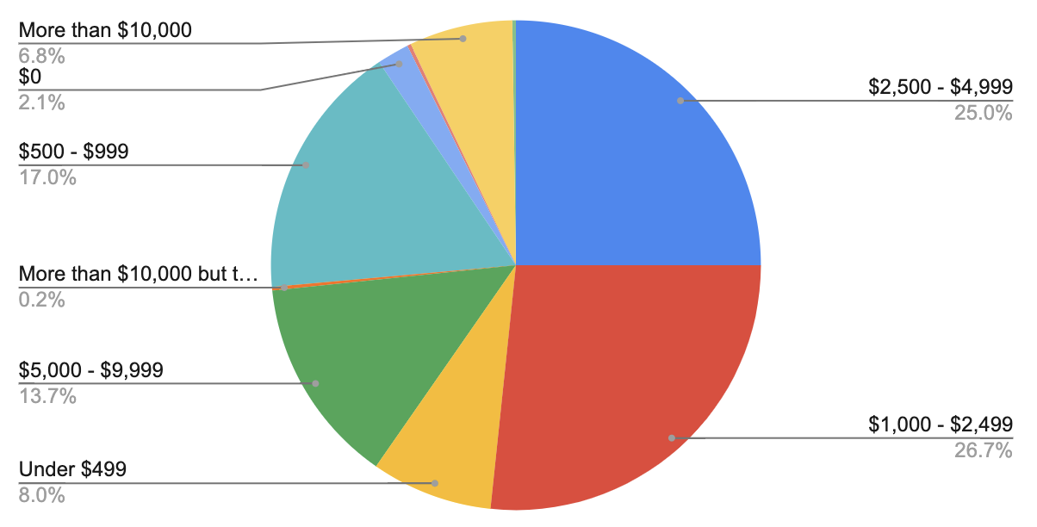
If you are forced to cancel musical activities through the end of summer, how much additional income do you estimate you will lose?

COVID-19 Direct Impacts (cont.)

How severe do you expect the financial impact of COVID-19 to be on your career? (1 to 5, 1 is little impact and 5 is extreme impact)
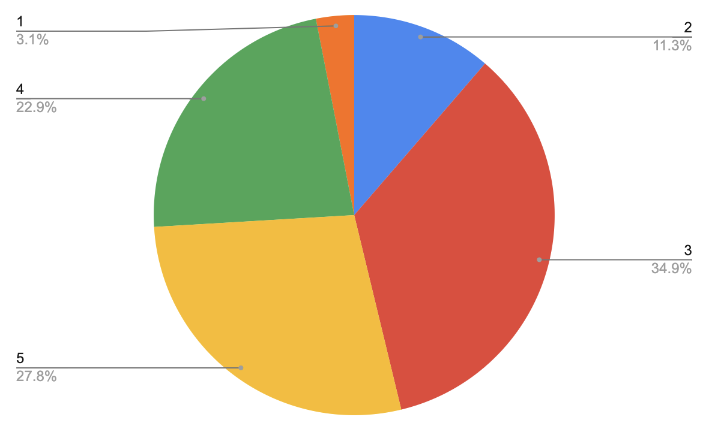

Have you experienced any unanticipated expenses as a result of COVID-19?
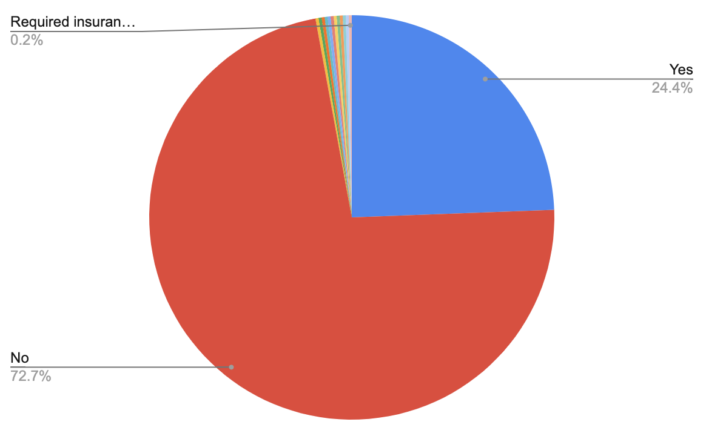
Of those who said “yes” summary of unanticipated expenses reported:
- Travel-related expenses due to canceled travel plans
- New equipment to move teaching/studio/performances online
- Health expenses
- Studio rent issues
- Family-related issues due to unemployment, health, etc.

COVID-19 Direct Impacts (cont.)

Do you fear that financial losses because of COVID-19 would make you have to... (check all that apply)
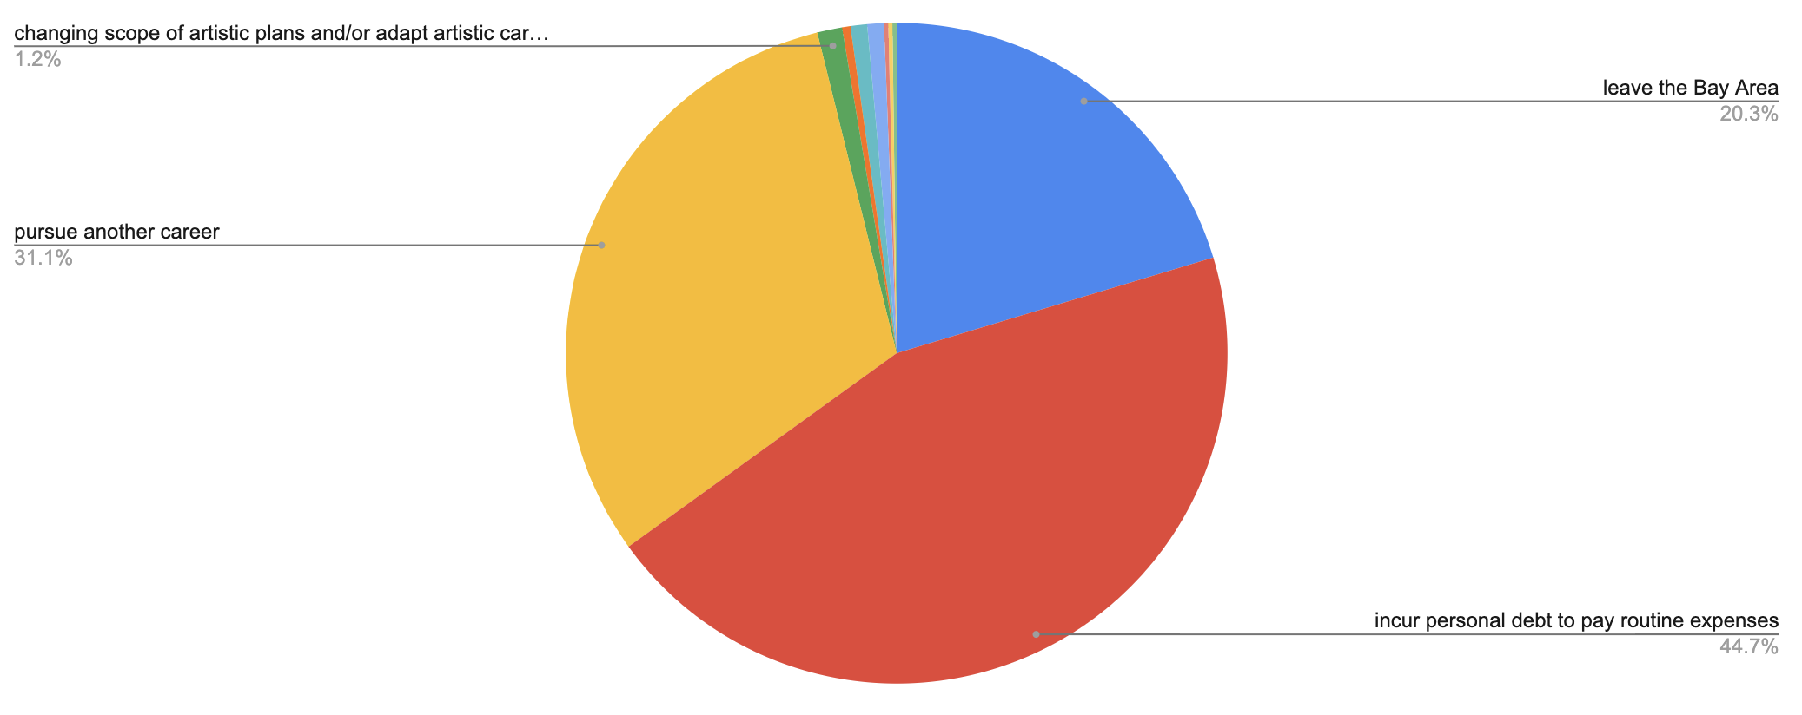
Other reported potential consequences included:
- Alter educational plans
- Adding a side job
- Live more frugally
- Alter retirement plans

Open-ended responses: Is there anything else you'd like to share about the impact of COVID-19 on you or your community?

Highlights and summary of common refrains:
- The impact is deep and should not be underestimated, it hurts arts workers all around from venues, to administrators, teachers, and performers.
- The lack of performances and social gatherings is troubling psychologically/emotionally.
- Some individuals voice positive thoughts about how it has brought our community together and allowed opportunities to refocus and take pause.
- Health effects could hurt players (esp wind players).
- The severity of the impact will largely depend on how long it lasts.
- Rescheduled gigs don't necessarily cover the loss, because musicians can't be in two places at one time and haven’t had time to rehearse.
- The landscape of the industry will change as a result.
- Some hesitate to file for unemployment for unintended consequences to future benefits or consequences to their employer.
- Not everyone understands the unemployment qualifications under the new CARES act.
- This crisis exposes the extreme fragility of the arts scene.

